**1.SVD**

import numpy as np

from scipy.linalg import svd

m1=np.array([[1,3,5,7],[9,11,13,15],

[17,19,21,23],[25,27,29,31]])

print("Matrix:\n",m1)

X,B,T=svd(m1)

print("matrix X:\n",X)

print("matrix B:\n",B)

print("matrix T:\n",T)

ad=np.add(X,T)

print("Sum of X and T is:\n",ad)

st=np.subtract(X,T)

print("Difference of X and T is:\n",st)

dt=np.multiply(X,X)

cb=np.multiply(dt,X)

sc=np.multiply(2,cb)

print("The matrix 2X^3 is:\n",sc)

**OUTPUT**

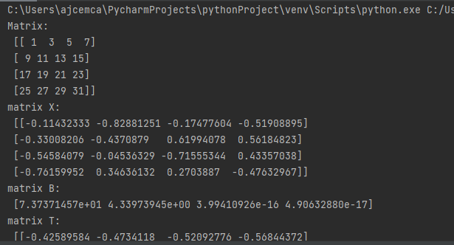

**2.CHUNKING**

import nltk

nltk.download('punkt')

new="The big cat ate little mouse who was after a fresh cheese."

new_tokens=nltk.word_tokenize(new)

print(new_tokens)

new_tag=nltk.pos_tag(new_tokens)

print(new_tag)

grammar=r"NP:{<DT>?<JJ>*<NN>}"

chunkParser=regexpParser.grammar(new_tag)

chunked=chunkParser.parser

print(chunked)

**OUTPUT**

